Hand Book of Information
Session ……………

Sri Sathya Sai Sr. Sec. School Anand Vilas

Affiliated with CBSE (1st to 12th)
[Governed by Sri Sathya Sai Trust, Himachal Pradesh]

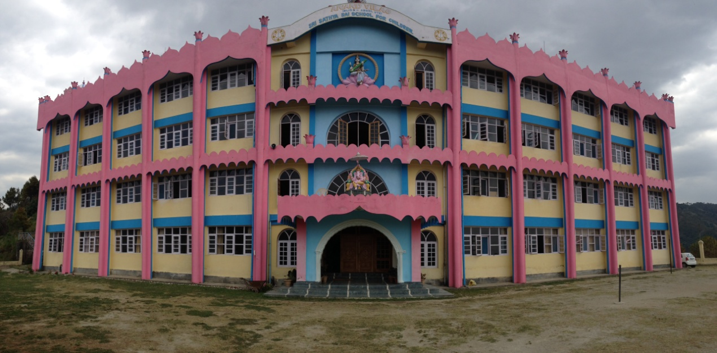
Why Fear, when I am here …. Baba

Sri Sathya Sai School Anand Vilas, Pujarli
Post Office Beolia, District Shimla—171013, Himachal Pradesh
Mobile No. 9816483527(P), 8894848936, 8894852975, 9816106607
Email: ssshimla@gmail.com Web: www.srisathyasaischool-anandvilas.com
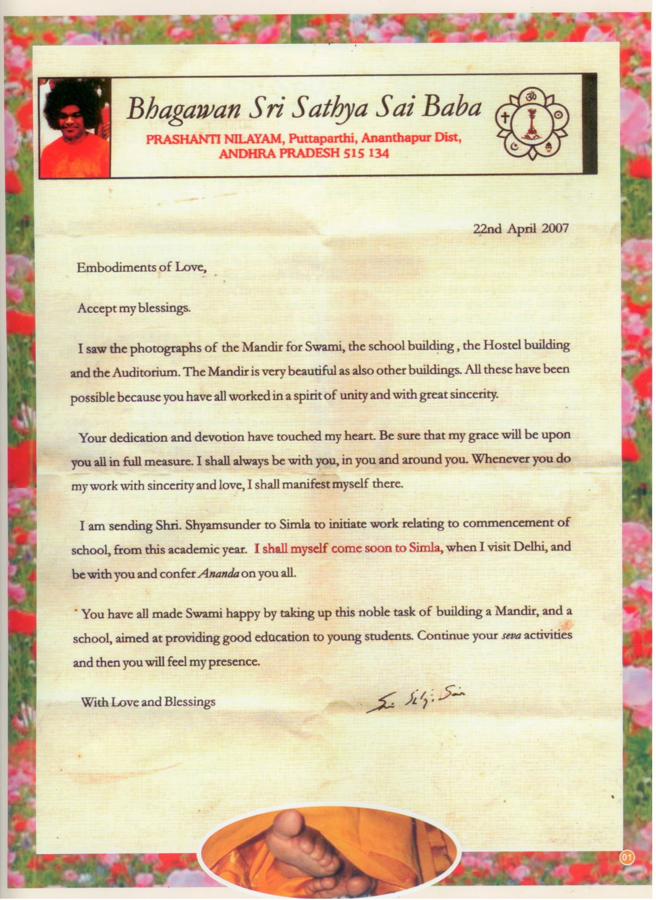
Om Sri Sai Ram
With our most humble prostrations at the Sacred Lotus Feet of Bhagavan Baba. We offer our deep gratitude to Him, who is the Yug Avtar. The entire mankind bows to Him with reverence and gratitude for the munificence and Grace He has showered on all, who have offered their respectful prayers. The whole mankind and the posterity shall remain indebted to Him who has showed them the righteous path to tread and be best among the mankind.
It is in reference to this, that He has given us Sri Sathya Sai System of Education in the present turmoil of character decadence, environmental pollution, and awful association and thus the inculcation of bad habits leading to decadence of society and nation at large. We all equally owe responsibility to this standing of the day.
It is in this connection that Bhagavan Sri Sathya Sai Baba has initiated this School at ‘Anand Vilas’, Shimla in the year 2007, is testimony of His Love for the people of Himachal Pradesh. One has to understand and appreciate it. Standing on the banks of Ganges, if one does not sip its holy water, can’t claim to be blessed soul. So is our fate and fortune, if the residents of Himachal Pradesh do not avail the opportunity, which has been made by Absolute divine Will of Bhagavan Baba and with the dedication of pure feelings of active workers of Sri Sathya Sai Seva Organization, Himachal Pradesh and add to re-further glory of the institution and with the immense grace of Bhagavan Sri Sathya Sai Baba the school is initiating the golden step by starting +2 classes from the session 2020-21. This shell lead to the perfect development of the students both the intellectual and intuitive. This shell make a personally indeed fine and perfection in life.
May Bhagavan Baba bless us with all intellect and intuition to make best use of this opportunity, where the School entrance is only at first class, Eleventh and other classes depend on availability of seats. The seats are limited and the admission is obligatory through test!
If the student is admitted, it is Shangri-La to one’s whole life, a future that is bound to be glorious with fulfillment.
Jai Sai Ram.
Prof. Dr. Shyam Sunder
Chief Administrator
Sri Sathya Sai School, Pujarli
Shimla (H.P.) 171013

The feeling of Heart
After paying obeisance at the sacred Lotus Feet of Bhagavan Baba, I wish to say that since ancient times the Himalayan Mountains have been the personification of resplendent beauty, purity, silence and serenity. It has been the place yonder beyond imagination. It’s where saints sages, the king and the Karma Yogis, professor and the philosopher have been striving to learn that which is beyond perception. Its environment products vibrates for the growth within and without, they have been striving for self-elevation and to understand the oneness of the Universe. They have been tying their best to impart the knowledge and show the path of wisdom to the mankind. It is still continuing. Such Majestic and magnificent, superb and splendid hills have been blessed by the Avatar of the age not once but thrice till this time. It is Bhagavan Sri Sathya Sai Baba, the highest manifestation of God who has assumed the Human Form to give joy and fulfillment to aspirations and prayers of inhabitants of the region made from eons to eons.
Bhagavan Sri Sathya Sai Baba has come to Shimla in 1973, 1975. We received Him at Woodville Palace, the Mall, Shimla. He was over joyous with the devotion of the people of Himachal Pradesh and promised that He will often visit Shimla. The Palace where He stayed got converted into a five star hotel.
Therefore, we the devotees of Himachal Pradesh started praying and thinking to buy a piece of land on which we could construct the Divine Residence. Availability of the proper place delayed the process.
It was the day of 15th February, 1982, at Brindavan when Bhagavan called us, the devotees of Shimla, for an interview. We showed him a map of a piece of land. He said that this is not a good piece of land. There are lot of trees and it is all slopes. But as a silver lining to the dark clouds, He commented, “is it given by the Government?” I caught hold of this point, “is it given by the government?” on reaching back to Shimla ; I immediately contacted District Collector Shimla, who has been a great devotee of Bhagavan Baba and my personal friend too. He immediately put his team on search of good piece of land. And they were successful in getting it. At that time, Shri Vir Bhadra Singh was the Hon’ble Chief Minister of Himachal Pradesh, who was intimate with me since my early youth. Everything was ready. But there was no Sri Sathya Sai Trust, Himachal Pradesh. And as per the law of the land, it could be not registered in the name of any outside agency. I prayed repeatedly and repetitively at the sacred Lotus Feet of Bhagavan Baba for the constitution of Sri Sathya Sai Baba for the constitution of Sri Sathya Sai Trust, Himachal Pradesh. The prayer were answered and on 25th January 1986, Sri Sathya Sai Trust, Himachal Pradesh was constituted at Dharmakhetra Bombay, with the affable efforts of revered Sri Indulal Shah, then, Chairman World Council of Sri Sathya Sai Seva Organization.
On return from Bombay. We immediately applied for the said piece of land of 30 acres. After getting through the official formalities, the land was purchased from the Government of Himachal Pradesh in the year 1987. Before it, the revenue papers were shown to Bhagavan Baba and due Divine approval was got. After the completion of the Sale Deeds, every step such as fencing of land till the construction of the entire campus such as School, Hostel, Devine Residence, Auditorium, Guest room etc. was undertaken with the Devine permission of Bhagavan Baba.
It was the day of 28th March, 2007 when Bhagavan Baba commanding me to start the school at Shimla from this very Academic session. He further instructed me to start up to the 5th Class. Every classes shall go on increasing from year to year. For my further clarification, I pryed to him. Weather it should be for boys or girls. He graciously said that up to 5th class, it is should be co-education. After that it should be separate. Then I very humbly prayed at His Sacred Lotus Feet that what should be the name of Institution. By His Divine Mercy, prompt came the reply “Anand Vilas”.
And to continue his Divine Grace and Mercy on the people of Himachal Pradesh that on 22nd April 2007, He wrote a beautiful letter to the people of Himachal Pradesh. He promised out of His Sheer Divine compassion that He will visit Shimla very soon. And he did came.
All the description shall be incomplete, if it is not stated, that “Anand Vilas” before completion was nothing but a sloppy hill with haphazard area. It was all stony without any passage to walk. It is through the tough and hard work of devotees of Himachal Pradesh “Anand Vilas” got present splendid structure. It was the Divine will of Bhagavan Baba that fructified in the present impressive and imposing monument. This grand and superb construction and configuration is nothing but the testimony of love and co-operation, faith and solidarity, dedication and sacrifice. This is a humble offering at the Sacred Lotus Feet of Bhagavan Baba from the simple and innocent people of Himachal Pradesh.
With His Divine Grace and true to His Divine Words, Bhagavan did come to Shimla on 15th April, 2010, and inaugurated each and every building and the temple within the campus “Anand Vilas”.
With His Divine blessings of Sri Sathya Sai Baba it is a proud movement for me to announce that Sri Sathya Sai School Pujarli is starting 10+2 classes from the session 2020-21.

Member Secretary
Sri Sathya Sai Trust, Himachal Pradesh

Location
It is located on Shimla-Junga road near Village Pujarli. It is at a distance of 15 Kms from Local Bus Stand Shimla. Local bus facility is available from Local Bus Stand.
The school is situated amidst lush green verdant hills in serene and calm atmosphere. The meandering rivulets render the atmosphere a divine ambience. The four storied majestic school building and the four storied hostel with all modern amenities are complete in all respects. The school and hostel are located on the adjoining hills and are interconnected through a glazed corridor, which helps students to go to the school during rainy, rough and snowy weather.
With the grace of Bhagavan Baba, the school functions under the guidance and governance of Sri Sathya Sai Trust, Himachal Pradesh. It carries out the lofty ideals of Bhagavan Sri Sathya Sai Baba, i.e. “Character development with academic excellence”. This school caters to the development of skills as well as inculcation of good habits rooted in human values to lay the foundation of a noble character. To promote the feeling of brotherhood, patriotism and humanism are the prime features of the teaching goals. It makes the students grow with self confidence, self reliance and reverence suffused with the feeling of sacrifice and fortitude, so that they grow straight and strong to become ideal person, who can shape the destiny of the nation.
Let us all feel happy and blessed that Bhagavan out of infinite love and compassion gave the name ‘ANAND VILAS’ , to this holy and sacred campus, on most auspicious day of 28th March, 2007.
Vision
To emerge as an outstanding institution imparting education with a unique blend of modern science and technology with human values grounded in spirituality.
Mission
- To simulate and nurtured young minds which share excellence through active learning.
- To enable the children to become thinking, sensitive and responsible global citizens with a progressive outlook.
Objectives
This academic institution shall aim at developing a balanced personality keeping in harmony the synthesis of intellectual, ethical, emotional and spiritual standards. Therefore, all the programmes pertaining to teaching are structured for the students to learn and practice the qualities of:
- Self confidence with faith in God.
- Academic excellence.
- Life skills including communication and social skills along with analytical abilities.
- Maintenance of a well-nourished, healthy and agile physique.
- Inculcating the habit of a disciplined and regulated life.
- Developing an interest to participate in service activities.
- Harmonizing action with positive thoughts and sweet words.
- Developing respect and regard towards Indian culture and way of life.
- Showing reverence for parents and elders, and honoring the dignity of all individuals.
With the Divine permission and Grace of Bhagavan Sri Sathya Sai Baba, Sri Sathya Sai School, Anand Vilas up to Fifth standard was started in 2007 and 1ST Batch of 10th standard was started on 2012. Now with the divine grace of Sri Sathya Sai Baba School is starting 10+2 Classes session 2020-21. It is a 100 % residential school accommodating both staff and students. It is an English medium School.
Academic Result
With the divine, grace of Bhagavan Sri Sathya Sai Baba the result was 100% which is the 39 students appear in board Examination in 2018-19 out of which 8 students Secured in A1,7 students A2 grade. Credit of good result goes to the qualified and dedicated teaching staff.
Admission is open for 1st to 10+1 Standard for the session ……………..
Commencing from March …..………. Both for boys and girls.

Academic Session
The academic year of the School starts from March to December every year. It will have winter vacation in the months of January and February and also a short limited summer break and Dewali Holidays (Dated to be announced later).
Winter Vacation: January and February
Summer Break: 10 Days
Diwali Holidays: 7 Days
House Test Schedule
First Term: March to July (2 House Tests)
Second Term: August to December (2 House Tests)
Admission Rules
- For admission in 1st Class the age should be 5 years 6 months plus, not exceeding 6 years 6 months in March of academic session in which admission is sought.
Note: The age proof certificate of the candidates seeking admission in class 1st should be issued by the competent authority (Secretary Gram Panchayat, Nagar Nigam and Nagar Panchayat) where the child has born.
- Admission in the 1st Class will be made on the basis of Draw system in the month of December, As per on notify by the office.
- The students seeking admission 1st Class should have passed in K.G. Standard.
- The candidate seeking Admission in Class 2nd to +1 should enclosed in the last three years Class performance report of their respective school.
- Prospectus along with admission application form can obtain from the office hour by paying Rs. 300/- I cash or through Demand Draft of Rs. 350/-(including postal Charges) in favour of Principal Sri Sathya Sai School Anand Vilas, Pujarli, P.O Beolia Distt- Shimla-171013.
- The parents/guardians have to give an undertaking that they would ensure that the child abides by the rules and regulation of the school.
- The school will keep close vigil over the conduct of the child. In case the child fails to observe the code of school, the administration reserves the right of admission after providing ample opportunity.
- The student may be denied from further admission in higher class if his/ her academic progress is not up to the mark and becomes over age
Academic Curriculum
The School is affiliated to the Central Board of Secondary Education (CBSE) New Delhi Vide Letter No. CBSE/AFF/MS-00646-0910(630152)/2011 & Upgraded up to +2 vide Letter no. CBSE/AFF/630152/SS-00490-1920/2019-20 DATED 24TH OCTOBER, 2019.
The school follows the co-curriculum prescribed by Central Board of Secondary Education, New Delhi. The following subjects are offered for 1st to +2 classes.
English, Hindi, Sanskrit, Mathematics, Science, Environment studies, Computer, Social Studies and Physical Education.
Science Stream for +1 and +2 classes
Medical: Chemistry, Biology, English, Computer/ Physical Education.
Non-Medical:- Physics, Chemistry, Mathematics, English, Computer/Physical Education.
Commerce Stream:- Accountancy, Economics, Business Study, Mathematic, English, Computer/ Physical Education.
A part from these every students will give vocational training in aspects such as:-
Art & Craft, Drawing and Painting, General Knowledge, Education in Human Values and Yoga,
Besides, the school has extra Curriculum activities for the holistic development of the personality of the child by teaching human value as per the teaching of Bhagavan Sri Sathya Sai Baba. All the activities are designed to bring out the hidden inherent talent of the child through integral program of Education as delineated by the Bhagavan Sri Sathya Sai Baba.
Teaching Methodology
The school utilizes all the modern technique of teaching in the classrooms including Smart Class. The Sathya Sai Educational institute follows there approaches of teaching in human values they are:-
(i)Direct Approach, (ii) Indirect or Incidental Approach (iii) Integrated Approach.
Direct Approach
The Direct approach consists of five major techniques, namely Silent Sitting (Tuning-In), Prayers, Group Singing, Story-Telling and Group Activities.
Indirect or Incidental Approach
In the incidental approach, the teacher takes the advantage of a chance incident as it arises in the classroom, in the school campus, or on the playfield to teach a value by correcting, praising or discouraging certain behaviour. The chance incident is used to develop any of the basic values. Sometimes, the situation can even be created by the teacher to see the reaction of the students to assess their value approach.
Integrated Approach
The third approach for inculcating values is the integrate values with curricular and co-curricular activities, whenever and wherever one may get opportunity do to so. This method has been found to be very useful as it does not require extra time for imparting values.
In integrated approach the students are inculcate and integrate the values with curricular and co-curricular activities, this method has been found very useful as it does not require extra time for imparting values.
Integral Education Activities
The school has a wide range of co-curricular activities, which focus at nurturing the physical, mental, emotional and spiritual aspects of the child’s personality. The lists of such activities are as under:-
Veda and Stotra Chanting, Bhajans, Yoga, Dramatics, Public Speaking, Story Telling, Essay Writing, Debate and Elocution, Quiz, Socially useful productive work, Work Experience, Art & Craft, Display of students skill by purring in exhibition once in a year, Integration of intellect and intuition etc.
These activities are meant to develop communication as well as, practical skills and perceptual ability apart from proper utilization of leisure.
Sports Activities
The school provides sports facilities for the students to encourage healthy competition, character building and physical stamina, self-confidence, emotional stability and team spirit. Inter house competition in various indoor and outdoor games such as, Kho-Kho, Badminton, Chess, Table tennis, Volleyball and Track events etc. The Annual sports day is celebrated in the month of October/ November where all the parents of the students are invited
School Library
The school library provides wide range of books, audio-visual material and periodicals on different subjects. It subscribes also selected periodicals, journals, magazines and newspapers.
Laboratories/Smart Class Room
There is a well-equipped science laboratory with latest science material, charts, model, specimens to conduct practical as per the guideline of CBSE. A well developed Computer Laboratory with Multimedia Projector and Internet facilities are available within the School campus. All students are given practical computer knowledge beside this Mathematics laboratory is also available as per the CBSE norms. The School has Smart Class rooms with Internet Facilities and intensely use by the teacher.
Prayer Hall
The school has a big prayer hall befitting the educational philosophy of the school. It is the most sacred place of the school premises where daily prayers and meeting are organized.
School Uniform
The school has a specific uniform code, that is provide by the institution on the payment basis.
Uniform Detail
Boys (I to XII)
- Sky blue shirts (2), dark navy blue pants (2), One pair black shoes (1), two pair of grey socks (2), two pair of woolen socks (2), School tie (1).
- White shirts (2), navy blue sweaters (2), blue blazer (1) and white pants (2), Track Suits (2), One pair of White Shoes(1), Two pair of white socks (2).
Girls
Girls (Class I to V)
- Pink skirt (2), White shirts (2), One pair of black shoes(1), two pair of grey socks(2), two pair of woolen socks(2), School tie (1).
- White skirts (2), Navy blue sweaters Full Sleeve (1), Navy blue sweaters Half Sleeve (1) blue blazer (1) and white shirts (2), Track Suits (2), Two pair of white socks (2), One pair of white shoes(1).
Girls (Class VI to XII)
- One Pink Suit with white dupatta
- One plain maroon suit with white dupatta.
- One white suit, one blue cardigan (sweater Full Sleeves), One blue cardigan (sweater Half Sleeves), Two pair of White socks, one pairs of White shoes and Black Shoes.
Employee’s also adhere this dress code of Sri Sathya Sai School.

Books and Textbook
The Books are available in the institute on payment basis.
Examination and Promotion
The student shall be promoted to the higher class based on following criteria:
- Class Work and Assignments
- Unit Tests
- Mid-term Examination
- Annual Examination
- Project Work/Practical Work
- Performance in the Integral activities.
The Evaluation/ grading system is being followed in the school as per CBSE guidelines. It emphasizes on the grading system. The student getting less then 33 % below or are scoring E grade will be given chance to improve their percentage / grade to get promotion to the higher class up to 8th standard.
Leave Rules
- The student shall not remain absent from the school without prior permission of the Principal/ Warden with the consent of the chief Administrator. The application for leave must come from the parent/ guardian.
- Students shall not leave school premises during school hours.
- For long absence from the school, prior permission from the Principal shall be needed with the consent of the Chief Administrator. In case of absence from the school for more than seven consecutive days without leave, the name of the student will be struck off from the school rolls provided ample opportunity.
- All the students are required to attend the school on the reopening of school after vacation.

Discipline
Maintenances of discipline, hard work and obedience are the fundamental principal of education institution. The school follows strict discipline with regard to the work and conduct of the child. The guidelines to the students and guardians are given in the elaborated on pages no. 8.
Medical Facility
The school has adequate facilities for taking care of the health of the children. The services of specialized doctors are also available for looking after their well-being. Periodically general medical checkup are carried out by the doctors impanels by the institution. All the new admission students must attach medical fitness certificate issued by the medical officer.
Hostel Facilities
The school provides all weather hot water facilities in the hostel. There is well furnished spacious dining Hall with well ventilation and kitchen is equipped with modern cooking gadgets.
Food and Refreshment
A well-balanced, wholesome vegetarian food and milk is served to the children. In case of sickness, diet is served, as per the doctor’s advice.
Daily Schedule of Institution
- Wakeup Call (Daily) 05:00 AM
- Suprabhatam/Jogging (on alternative days for boys & Girls) 06:10 AM-06:35 AM
- Breakfast (Shift Viz.) 06:35 AM -07:45 AM
- Morning Assembly 08:10 AM -08:30 AM
- EHV Period (Activities based on Human Value) 08:30 AM -08:45 AM
- Ist period to IIIrd period (Each Class of 35 minutes) 08:45 AM -10:30 AM
- Snacks Break 10:30 AM -10:45 AM
- IVth period to VIth period (Each Class of 35 minutes) 10:45 AM -12:30 PM
- Lunch Break (Shift viz.) 12:30 PM -1:40 PM
- VII & VIII period (Each Class of 35 minutes) 01:40 PM -02:50 PM
- Supervise Preparatory Period (I Period and II Period) 03:00 PM -04:00 PM
- Snacks with Milk Break (Shift viz.) 04:30 PM -06:00 PM
- Playing Time 05:00 PM -06:00 PM
- Evening Bhajan (followed by Jyoti Meditation on Thu, Sun.) 06:20 PM -07:00 PM
- Dinner (shift viz.) 07:05 PM -08:15 PM
- Self study after dinner (for Senior Class) up to 10:00 PM
Note: Every Friday there will be Bal Vikas Classes from 3:00 PM to 4:00PM and Saturday will be Half teaching day .
Visitors/Guests
Parents/Guardian may visit to meet their ward on second Sunday of every month between 09:00 AM to 5:00 PM (Summer) and 09:00 to 04:00 (Winter). They should contact or call Warden/Teacher-In-Charge bringing in the notice of the Chief Administrator before permitting parents/Guardian to meet their Ward. Parents/ Guardian are requested to adhere the timing strictly.
Essential items
The following items are essential for the hostel life and each student must bring with him/her at the time of joining the hostel. The Items are listed bellow:-
Items to be provided by School from Students Welfare Fund
- Track Suit (02 Sets)
- T-Shirts (01Set)
- Mattress for New Admission
- Pillow Cover (02 nos.)
- Bed sheets (02Nos.)
- Sketch Pens Set
- Stationery items
- Toothpaste, Oil, Soap, Toothbrush etc.
Items to be provided by Parents
- Night Dress (02 Sets Girls)
- Inner Garments (Girls 06 pair)
- Inner Garments (Boys 04 pair)
- Night Dress (Kurta & Pajama) (02 Pair)
- Woolen Pullover (Dark Gray & Brown for Boys(01 each)
- Woolen Pullover (Black and Maroon for Girls) (01 each)
- Sports Shoes White (02 Pair) Good quality
- Woolen Socks (02 pair)
- Sleeper (01 pair)
- Blanket (01 nos.)
- Pillow (01 nos.)
- Quilt (01 Nos.)
- Quilt Cover (02 Nos. Coloured)
- Geometry Box (01 Nos.)
- School Bag (01 nos.)
- Water Bottle (01 nos.)
- Makintush (Momjama) (02 Pair) (Only 1st to 3rd Class)
- Mirror and Comb (01 each)
- Two Locks
- Bath Towel for Boys (Plane Brown Big) (01 nos.)
- Bath Towel for Girls (Dark Blue Big ) (01 Nos.)
- Hand Towel for Boys Brown (01 nos.)
- Hand Towel for Girls Dark Blue (01 nos.)
- Hangers (06 nos.)
- Spectacles (02 Nos.)
- Torch mini size (01 nos.)
- Snacks Bowl with spoon (01 nos.)
- Yoga mat (01 nos.)
- Trunk/Attaché ( Height 9” , width 22” ,Length 24”)
- 100 nos. Tags (Each & every cloth item should be well tagged)
Sample of Tag 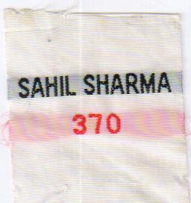

Hostel Regulations
“The Hostel is a home where each lives for the other and all live for God”, says Sri Sathya Sai Baba. Every student is given the opportunity and necessary training to develop his/her character suffused with human qualities such as love, co-operation, sacrifice and forbearance. In this process, every student is expected to behave in the most disciplined manner and abide by the following regulations:
- Humility is the firm foundation for the making of a noble character. Every student will practice obedience and respect to elders and brotherliness with co-boarders.
- All students should wear decent and unostentatious dress. They should have short, neat and well-groomed hair and not to support moustache, beard or long side burns.
- God’s voice is heard in the depth of silence, therefore, the students should maintain perfect silence and not indulge in idle gossips and loud talks.
- There is no provision for leaving hostel without permission. Overnight stay outside hostel is forbidden.
- Students are allowed to go home only during vacations and duly authorised leave along with the parents/ Guardian and submitting ID proof at the time of Admission.
- Visitors are not allowed to enter the Hostel premises. Parents and guardians are requested to visit their wards, preferably only on second Sunday of every month between 9 am to 5 pm. In case of any urgent situation, they may meet their wards, with the permission of the Principal with the consent of Chief Administrator during the Class hours.
- Telephonic conversation with parents is allowed on telephone Mobile number 98161-06607, 88948-52975 and 88948-48936.

Day Timings
6:45 am -7:45 am 5:45 pm-6:45pm 6:45 pm-7:45 pm
Monday Class I (Girls) Class X (Girls) Class I (Boys)
Class XI (Boys) Class XI (Boys)
Tuesday Class II (Girls) Class IX (Girls) Class II (Boys)
Wednesday Class III (Girls) Class VIII (Girls) Class III (Boys)
Thursday Class IV (Girls) Class X (Boys) Class IV (Boys)
Friday Class V (Girls) Class IX (Boys) Class V (Boys)
Saturday Class VI (Girls) Class VIII (Boys) Class VI (Boys)
Sunday Class VII (Girls) Class VII Boys (7:45 am -8:45 am)

“Parents are requested to restrict their telephonic conversation with the ward to a maximum of three minutes in view of many incoming calls.” No telephone talk is allowed during examinations.

- Punctuality and regularity in classes, prayers, tests, examinations and all co-curricular activities in the school and the Hostel are compulsory. In case the student is unable to attend class/programme or any of other programmes, on account of illness, he is required to seek permission/leave from the Principal and Warden.
- Early to bed and early to rise is good for health. ‘Hence, the students should go to bed soon after night prayer.
- Besides textbooks, students are permitted to read spiritual literature and magazines such as Nav Sarthi, Bhagavan’s Journal, Snathan Sarthi, Bal Vikas, magazine which build strong and pure mind.
- ‘Cleanliness is Godliness’. Hence all the students are required to maintain high standard of personal cleanliness of room and its surroundings with the felling of personal property.
- The students Can’t keep cash with them. In no case, parents are not allowed they must deposit the money. Received from parents in the stores account without delay. Whenever required they can withdrew the money from their stores account after getting permission from their wing teacher. Parents can deposit the cash into the stores account of their ward for any kind of expenses. Every student should follow the dictum given by Bhagavan Baba: “Don’t waste time, time waste is life waste; don’t waste food, food is God; Don’t waste money, misuse of money is evil”.
- Personal possession of tape recorder or transistor, video games, mobile phones, Electronic gadgets etc. are not allowed.
- In the interest of the child, the parents are advised to meet the Principal, Warden and the Wing teacher at least twice in a term between 09:00 am to 1:00 pm on second Sunday to know the performance of their Ward.
- Students must participate in all spiritual practices with proper enthusiasm. As this Institution is found to promote Spiritual Awareness, students should willingly make effort to develop Spiritual Strength.
- Any breach of the above rules and regulations by the student after proof will be dealt seriously. Also, a student may be expelled from the Hostel and the School at any time if his/her behaviour is found unsatisfactory.
- The Parents / Guardians may submit Undertaking on prescribed Performa.
Guidelines to the Parents/Guardians
The parents/guardians are requested to note the following points:
- The school calendar is well defined schedule of Tests, Terminal Examinations, Vacations, Curricular Activities etc. is made available with the commencement of the academic session every year. Wards have to be pickup and drop as per the dates given in the calendar.
- Students are strictly not permitted to keep any money or other valuables with them.
- Please do not bring any eatables to their ward during visiting day.
- Any child having health problem of any kind must submit photocopy of the medical report and prescription as advised by the doctor so that proper care may be taken.
- Each Students welfare funds will be maintained by the Students storekeeper. Every student maintains a Recoverable Expenses Account in the School Store. The expenses incurred by him/her on the items issues from the School Store will be settled at the end of each session.
- Boys must have proper hair cut before they report back to hostel.
- Personal clothing and other items must be brought along as per the list given in this prospectus.
- Children whose dues will remain pending after due date their name removed from the rolls and they will not be permitted to attend classes.
- Selected candidates of all classes, have to deposit the following amount by the specified date.
  - Security fees (refundable) Rs. 1000/-
  - Bi-Annual Lodging, Boarding and
Other Charges (non-refundable) as per fee table
  - Bi-Annual Tuition Fee (non-refundable) as per fee table
  - New Admission Rs. 12000/-(for Uniform Charges, Books, Mattress
Charges and bed sheets etc.)
  - Welfare Fund for all Rs. 4000/- (for meeting expenses of washing Charges Hair cut, miscellaneous common expenses, etc.)
  - Old Students The charges for Uniform, Bed sheets, Mattress
Text Books, Pillow Cover etc. will be made on demand/ requirement Basis.
  - Mattress Charges (New Admission Only) Rs. 2000 (non-refundable)

How to reach The School
With the Divine Grace of Bhagavan Baba, after reaching the Shimla Old Bus Stand, one should follow the following route: Shimla Bus Stand-Chhota Shimla-Kasumpati –Mehli-Junga Road
From Mehli, the school at Anand Vilas is located at distance of about 5 Kms. on Junga Road. The local bus facility is available from Shimla old Bus Stand.
Let us all meet for the cause for the up-liftment of the individual and the society, bearing in minds that, “Education is for life, not merely for living”.
Published by: Sri Sathya Sai Trust, Himachal Pradesh ‘Sai Shruti’, D-3, Strawberry Hill, Shimla-171002
Note:- The Students leaving the Institution information must be brought in the notice of the Chief Administrator.
Important Admission Information for Parents/Guardians
- Prospectus for admission to I-VIII standard will be available in
Anand Vilas from Mid of October and the last date of receiving the application form shall be………. November every year (if not stated otherwise).
- Admission Test for both written and oral will be held at Anand Vilas on ……….December for I-V class and on ……….December for classes VI-VIII at 10:00 A.M respectively. The selected candidates will be given admission with in 10 days of selection.
- No separate information will be given for appearing in admission test. All those who apply before 23rd November will be allowed to sit in the admission test on the production of Identity slip given below
- All the candidates admitted in the school will report on first week of March, …………. for which information will be provided separately. The parents/guardians may kindly note that the wards must bring with them all the items mentioned in the Prospectus.
- Classes will start from March ………………..
- More information can be had by dialing phone number 0177-2751377 (Principal Office) Mob.No. 9816483527 or 2751577 (Hostel) (Warden) 99156-51426, 99580-50659 (Administrator) 99156-51437
- The application form should be sent on the address given below: The Principal, Sri Sathya Sai School, Anand Vilas, P.O. Beolia, District Shimla, Himachal Pradesh Pin Code-171013.

Fee Structure for the Session 20…….
Fee Detail
CLASSES TUITION FEES OTHER CHARGES BOARDING & LODGING
D/D Only D/D Only
IN FAVOUR OF PRINCIPAL ANAND VILAS WARDEN ANAND VILAS
SRI SATHYA SAI SCHOOL SRI SATHYA SAI SCHOOL
I-II Rs.15000/-(Annually) Rs.5000/-(Annually) Rs.37000/-(Annually)
III-V Rs.15000/-(Annually) Rs.5000/-(Annually) Rs.41000/-(Annually)
VI-X Rs.18000/-(Annually) Rs.5000/-(Annually) Rs.44500/-(Annually)
XI-XII Rs.38400/-(Annually) Rs.5000/-(Annually) Rs.47000/-(Annually)
XI-XII Medical Stream Rs. 700/- (Monthly) Practical charges
XI-XII Non-Medical Stream Rs. 500/- (Monthly) Practical charges
Note:-Other charges include as Electricity, Water, and Sports etc.
Fee can be deposit in one time or two installments through Bank draft/Electronic mode to Warden Sri Sathya Sai School for Boarding and the tuition fee will be paid by a separate bank draft/ Electronic mode drawn in favour of Principal Sri Sathya Sai School, Anand Vilas Shimla. While using online mood of transaction mentioned name of students & admission No. to avoid the lapse.
The first installment must be deposited within 10 days from the final selection list displayed by the school and the second installment must reach the office latest by 31st July failing which Rs 10/- per day will be charged from students within 10 days after that this late fee will be recovered form the students welfare Account.
Bank detail of School A/c
Account No:- 30170621189
Name of Bank A/c:- Principal Anand Vilas Sri Sathya Sai School for Children
IFS Code:- SBIN0000718
Branch:- SBI Main Branch Shimla.

Bank detail of Hostel A/c
Account No:- 30170619759
Name of Bank A/c:- Warden Anand Vilas Sri Sathya Sai School for Children
IFS Code:- SBIN0000718
Branch:- SBI Main Branch Shimla.

Bank detail of Students Sahayak Store A/c
Account No:- 05650110003848
Name of Bank A/c:- Sri Sathya Sai Students Sahayak Store
IFS Code:- UCBA0000565
Branch:- UCO Bank Kasumpti.

ONLY SECURITY FEE IS REFUNDABLE
Om Sri Sai Ram
Sri Sathya Sai School at ‘Anand Vilas’, Shimla is an ancient Gurukul’ or modern hermitage with all modern amenities and facilities. It is residential School, where modern technology and teaching, serenity and silence and science and spirituality are synthesized. It is a place where the students are made aware of academic curricula, modern advances in Science and skill along with their participation in Bhajans, Mantra recitation and group activities, and outplay in sport and art activities. Thus, it may lead to the integral development of intellect and institution. It is to live in practicing the philosophy of Bhagavan Sri Sathya Sai Baba, who says,
“Money comes and goes,
Morality comes and grows,
Love flows,
And Lust is thorn.”
Thus, the good habits inculcated in student life shall go a long way in the perfect development of life. More the toughness more shall come the sheen in life.
Men may come, men may go, but luster of Institution will go forever. If one abides by the law of Firm/Institution and law of the land, one is most happy and blissful. This Institute is an example of awareness and dedication, love and morality and keenness for the welfare of the child. Let us all contemplate on it and live up to Ideals of Sai School and to the Glory of name of SAI. May the parents the members of the teaching profession and children make best use of this opportunity by their association with it!
May SAI be ever with us as guide and guardian, our strength and sustenance, solace and support! And the life of all be happy and blissful.
Jai Sai Ram
Prof. Dr. Shyam Sunder
(Chief Administrator)
****************************************************************************

Anand Vilas

Sri Sathya Sai Sr. Sec. School Anand Vilas

Photograph
Passport size

Application Form for Standard...............
Anand Vilas, Post Office Beolia
District Shimla, Himachal Pradesh
Pin –171013 Phone: 0177-2751377
0177-2751577, 9816483527

District Shimla, Himachal Pradesh
Pin –171009 Phone: 0177-2751377

Serial No
FOR OFFICE USE ONLY
Regd.No. Admission No.
(to be allotted at the time of admission)
PRINCIPAL
23rd November 20……..
Last date for Submission
- Name of the Candidate (IN BLOCK LETTERS) in English …………...……………………………………………………………
…………………………in Hindi ……..……………………………………………………………………………………………………………….
- Sex: Male/Female……………………………….................................................................................................
- Date of Birth ……………………………. in words …………… ……….......................................................................
- Age as on (31.03.20……)..................................in words …………Year(s)............Month(s)...................Day(s)
- a) Father’s Name (IN BLOCK LETTERS) in English ……..…………………………………............................................
in Hindi ……..…………………………………………….. …………...................................................................................
b) Mother’s Name (IN BLOCK LETTERS) in English …………………………………………………………………………………
in Hindi ……..…………………………………………….. …………....................................................................................
c) Permanent Address ……………………………………………………………………………………………………………………………
……………………………………………………………………………………………………………………………………………………………….
………………………………………………………………………Pin Code………………………………………………………………………….
d) Address for Correspondence..……………………………………………………………………………………………………………..
………………………………………………………………………………………………………………………………………………………………..
……………………………………………………………………Pin Code ……………………………………………………………………………
e) Phone Number with STD code:…………………………… Mobile Number:…...………………………………………………..
f) E-mail:…………………………………………………………………………………………………………………………………………………….
- Occupation of Father………………………………………….. Annual Income……………………………………………………………
- Occupation of Mother ..........................................................Annual Income..................................................
- Categories General, SC, ST,OBC ...............................................(In case a person is not filling the information he will be consider as General) Attached Certificate
- Mother Tongue………………………....Religion………………………..Nationality……………………………………………………….
- Name of the last school attended……………………………………………………………………………………………………………….
- Affiliated to which Board…………………………………………..Recognized /Unrecognized
- Whether the candidate’s brothers/sisters studied in Sri Sathya Sai Educational Institutions, give details……………………………………………………………………………………………... ……………………………………………………….
……………………………………………………………………………………………………………………………………………………………………
- Fill in the result of the qualifying examinations (Not applicable for class I):……………………………………………….
- Whether the candidate was a student of Bal Vikas of Sri Sathya sai Seva Organization.
……………………………………………………………………………………………………………………………………………………………………
- Candidate’s record in games & sports/Yoga/Music/Other activities.
…………………………………………………………………………………………………………………………………………………………………….
- Aadhar Card no.

DECLARATION
I undertake to abide by rules and regulations of the school in respect of academics, sports, Extra-curricular and other activities, code of conduct and discipline and moral education as given in the prospectus. In the event of any act of indiscipline on my part the decision of the Principal shall be final and binding on me.
Signature of the Candidate
a) I endorse the above statement of my son/daughter/ward.
b) I hereby declare that the date of birth in respect of my son/daughter (name)…………………… ……………………………. furnished in column No.3 is correct and that I would not demand any change in it later on.

Date………………….. Signature of the Parent/Guardian
Note: a) Photocopies of Date of Birth Certificate and Transfer Certificate be attached with the application form.
- Two copies of the latest photograph of the child must be submitted along with the application..
- Performance report of the student during last three years (Photo copies of report cards except I standard).
- Attach Aadhar card copy of student
- Medical Certificate (Annexure-I), Undertaking by Students/ Parents (Annexure-II) and Parents Identity (Annexure-III).
- Incomplete application is liable to be rejected.
Aum Sri Sai Ram
Annexure-I
Health Status of the Student of Sri Sathya Sai School
Anand Vilas, Shimla-13
Space for passport size photograph
Affiliated to CBSE

Name of the Student…….……………………………………………………………………
Admission No.: …………………………………………………………………………………
Height…………………………………..………………………….….……………………………..
Weight ……………………………………………………………..
Blood Group…………………………………………………………..….…………………….
Vision(left eye)…………….…… (Right eye) …….….…….………………………….
Dental Hygiene ……………………………………………………………

Signature of the Candidate
Signature of Guardians/Parents Signature of Medical Officer with stamp

UNDERTAKING BY STUDENT/PARENTS
Annexure-II
I Mr./Miss ________________________________ joining for __________________ year for the academic year ________________ do hereby undertake and abide by the following terms & conditions, I will bring the ACKNOWLEDGEMENT duly signed by me and my parent.
- I will attend all the classes from the reopening day/joining of the school on ____________ as per the time-table. In case, I do not turn up even after one week of starting of classes, I shall be ineligible to continue for the current academic year.
- I will report back to the school positively after every holiday/vacation mentioned in the school calendar without fail or any excuse.
- I will be regular and punctual to all the classes (Theory/Practical/Clinics/ Houses activities) and secure attendance of not less than 90% in each subject. I am fully aware that attendance less than 90% in any subject ill make me lose internal/external examinations/marks.
- I will not bring with me any electronic device such as mobile, mp3 and video camera etc. knowingly or unknowingly. If in any case, it is found with me by mistake I will handover it to the Principal immediately without delay. If I am found guilty for keeping these things knowingly suspension/expulsion/rustication of myself may be undertaken by the concerned school authorities.
- Only my parents/guardian mentioned and registered in record register with photograph will take me from the hostel/school premises to the home for vacation/medical checkup/ meet. I will not meet to anybody (relative/friend) during my stay in hostel/ school time not even for two minutes or five. Second Sunday of every moth will be parents/guardian meet with the students.
- I will compulsorily follow the dress code and uniform prescribed by Sri Sathya Sai School, Anand Vilas.
- I will conduct myself in a highly disciplined and descent manner inside the classroom, ground, Bhajan Hall, dormitory and in the campus, failing which suitable action may be taken against me as per the rules and regulations of the institution.
- I will not indulge in any indiscipline activities, suspension/expulsion of myself may be undertaken by the concerned school authorities.
- I will not indulge in or initiate bunking classes or else punishment deemed fitting for such activities may be met out to me failing which suitable action may be taken against me as per the rules and regulations of the institution.
- I understand that in case I am found guilty of any wrong information for misleading the institution, the institution is liable to take any necessary action against.
- My conduct in/off campus as well as in hostels is completely abide by the rules & regulations of school authorities and hostel committee. Found guilty in any conspiracy or in-disciplinary activities in hostel I am liable to be discarded from hostel within 24hrs.of the notification.
- Indulgement in harming the school property, I will be steamily responsible and school can penalize me from financial penalty, suspension, declination of internal marks, FIR or fine and even cancellation of admission.
ACKNOWLEDGEMENT
I have gone through carefully the terms of the above undertaking and understand that these norms are for my/his/her own benefit and improvement. I also understand that if I/he/she fail to comply with these terms, the school will be liable to take suitable action as per school/ institutions rules and law against my ward. I undertake that I/he/she will strictly follow the above terms.

Sign of Student ………………………….. Sign of Parent…………………………………………………….
Adm. No. ……………………………….. Contact No.:…………………………………...…………………
Class…………………………………….. Address:*………………………………………............................
………………………………………………………….
Paste here recent photographs of the parents
Annexure-III
Om Sri Sai Ram
Sri Sathya Sai Hostel, Anand Vilas, Shimla-13
Parents Identity Form
Admission No…………………………………………………
Name of the Student …………………………………….
Father’s Name Sh. …………………………………………
Mother’s Name Smt. ……………………………………..
Address for correspondence………………………….
Paste here recent photographs of the parents

(Signature of Warden with stamp)

………………………………………………………………………. (Signature of Warden with stamp)
…………………………Pin Code…………………… ……….
Telephone No. With S.T.D.Code…………………….
Father……………………Mother……………………………
(Signature of Father and Mother)

1. Local Guardian Identity Form (if any) (Signature of Warden with stamp)
Paste here recent photographs of the Guardian

(Signature of Warden with stamp)

Name of Guardian …………………………………………….
Address of Local Guardian………………………………….
……………………………………………………………………………
………………………………Pin Code…………………………….
Mobile No.………………………………………………………..
(Signature Of Guardian)
2. Local Guardian Identity Form (if any
Name of Guardian …………………………………………. Name of Guardian …………………………………….
Address of Local Guardian………………………………
……………………………………………………………………….
………………………………Pin Code…………………………
Mobile No.……………………………………………………..
(Signature Of Guardian)

Note:- Student will be allowed to meet or to be taken
Only by the person who have given identification in this letter.

Co-Curricular Activities
Cultural Activities
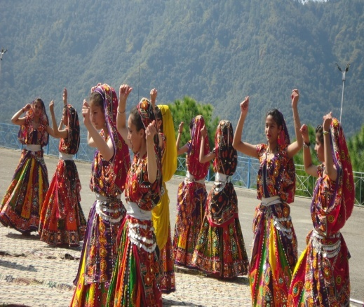
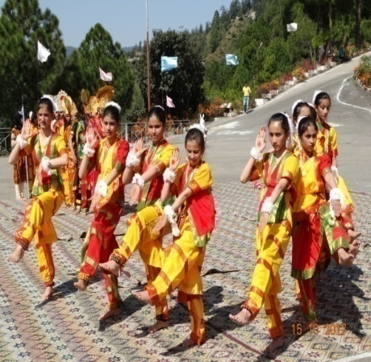
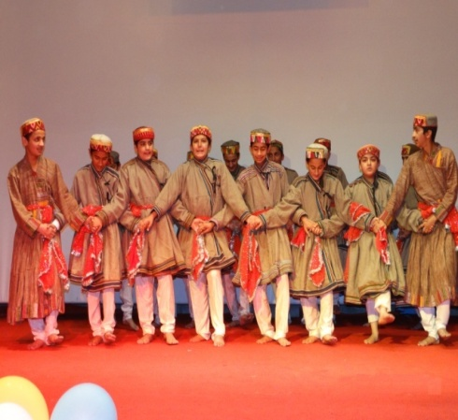

Performing Rajsthani Dance
Pahari NATI Himachal Pradesh
Performing Classical Dance
.
Sports Activities
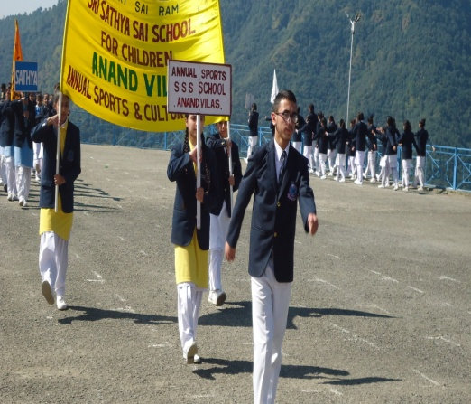
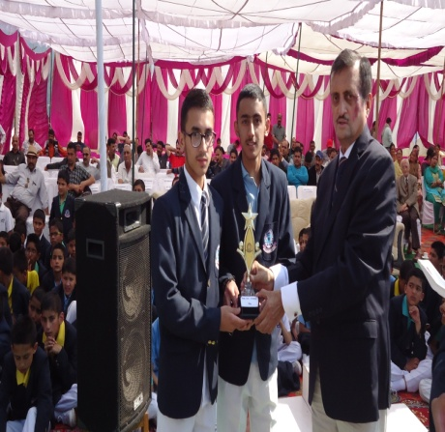
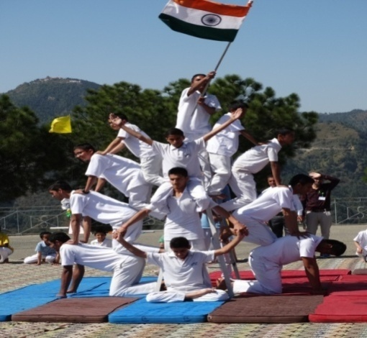

March Past by the Students
Chief Guest giving away Sports Prizes
Chanting of Veda
Cloth colour Painting
Pyramid formation by Students

Academic Activities
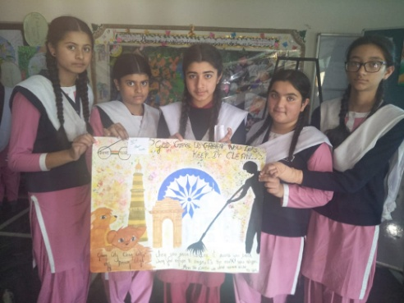
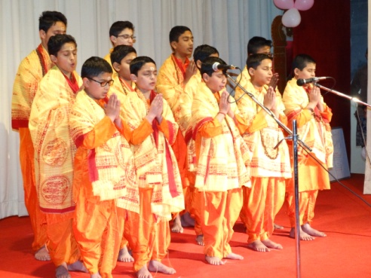
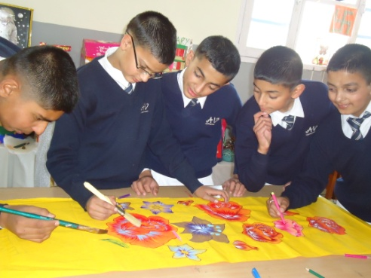

Environment Day Celebration

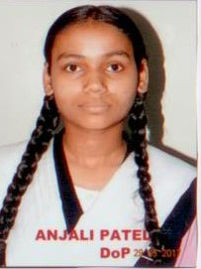
Lotus
Aishika Sharma

Anjali Patel
Suhana

Satyam
Pranav Bhardwaj
Shivam Kumar
Akshit Shyam

Published by:- Principal Sri Sathya Sai School, Anand Vilas, P.O Beolia, Shimla-171013
Printed by:-………………………………………………………………………….. Price Rs. 300/-

